**Content**

1.0 Electrochemical storage 1

1.1 Nickel–cadmium (NiCd) batteries 1

1.2 Nickel–hydrogen batteries 1

1.3 Nickel–metal hydride batteries 1

1.4 Nickel–zinc batteries 2

1.5 Lead–acid batteries 2

1.6 Sodium–sulfur (NaS) batteries 2

1.7 Sodium nickel chloride batteries 3

1.8 Lithium ion (Li–ion) batteries 3

1.9 Hydrogen energy storage (HES) 3

2.0 Mechanical storage 5

2.1 Pumped hydro energy storage (PHES) 5

2.2 Compressed air energy storage (CAES) 6

3.0 Electrical storage 7

3.1 Super capacitor energy storage (SES) 7

4.0 Thermal energy storage (TES) 7

4.1 Sensible heat storage: 7

4.2 Thermo-chemical storage (TCS): 8

5.0 Comparison of several storage methods 9

5.1 The price of several types of storage 9

5.2 Performance of several storage types 10

5.3 Environmental friendliness of several storage types 11

6.0 Transmission investment costs 12

7.0 The price of excess electricity 13

# **1.0 Electrochemical storage**

The desired battery is obtained when two or more cells are connected in an appropriate series and parallel arrangement, to obtain the required operating voltage and capacity for a certain load. In the market, there are many different types of batteries and most of them are subject to further research and development. In PV systems, several types of batteries can be used: Nickel–Cadmium (Ni–Cd), Nickel–Zinc (Ni–Zn) or lead-acid. The battery must have some important characteristics such as high charge or discharge efficiency, low self-discharge and long cycle life (Amrouche *et al*, 2016).

## 1.1 Nickel–cadmium (NiCd) batteries

The Ni–Cd batteries are commonly known as relatively cheap and robust. The positive nickel electrode is a nickel hydroxide/nickel oxyhydroxide (Ni(OH)2/NiOOH) compound, while the negative cadmium electrode consists of metallic cadmium (Cd) and cadmium hydroxide (Cd(OH)2). The electrolyte is an aqueous solution of potassium hydroxide (KOH). This technology is economically priced and presents the lowest per cycle cost. The Ni–Cd battery suffers from drawbacks such as the memory effect, the negative environmental impact of Cadmium and a high initial cost. So, it is not very advisable to use the Ni–Cd technology in renewable energy systems (Amrouche *et al*, 2016).

## 1.2 Nickel–hydrogen batteries

Nickel–hydrogen battery presents some advantages such as long cycle life, resistance to overcharge. It is generally suitable for space applications such as spacecrafts and communication satellites. But, the application of this kind of battery in renewable energy installations is limited by some drawbacks including a high initial cost, a high cell pressure and a low volumetric energy density (Amrouche *et al*, 2016).

## 1.3 Nickel–metal hydride batteries

These batteries are reasonably mature as a commercial product for automotive, medical applications and portable devices. Their use in renewable energy field suffered from some disadvantages such as a high self-discharge, a reduced cycle life and high pressure leading to failure. But actually, manufacturers are developing large capacity stationary batteries for the storage of the power generated by wind and solar sources [[17]](https://www.sciencedirect.com/science/article/pii/S0360319916309478#bib17), [[18]](https://www.sciencedirect.com/science/article/pii/S0360319916309478#bib18). As Ni–MH is much less environmentally problematic, they can easily replace Ni–Cd batteries (Amrouche *et al*, 2016).

## 1.4 Nickel–zinc batteries

The positive electrode is the nickel oxide but the negative electrode is composed of zinc metal. In addition to a better environmental impact, this type of battery has a high energy density (25% higher than nickel-cadmium). The Ni–Zn battery is cheaper than the Ni–Cd battery and is priced between the Ni–Cd and Lead acid technologies. The Ni–Zn battery has a higher energy to mass ratio and a higher power to mass ratio than the lead battery. Due to these reasons, the Ni–Zn technology has the potential to be used in renewable energy systems instead of both the Ni–Cd and lead batteries (Amrouche *et al*, 2016).

## 1.5 Lead–acid batteries

The lead–acid battery consists of two electrodes immersed in sulfuric acid electrolyte. The negative one is attached to a grid with sponge metallic lead, and the positive one is attached to a porous grid with granules of metallic lead dioxide. There are two types of conventional lead acid batteries: flooded (FLA) and valve-regulated (VRLA) [[8]](https://www.sciencedirect.com/science/article/pii/S0360319916309478#bib8). The flooded battery is cheaper than the sealed VRLA battery but requires a regular maintenance, and must be kept in a ventilated area in order to ensure the safe dispersal of the emitted gasses. The lead-acid batteries are the most used to support renewable energy deployment, especially in stand-alone power systems given that they are spill-proof, easy to transport and their relative lower cost compared to other types. However, the conventional lead-acid batteries suffer from various technical issues, mainly short cycle life (<500), low depth of discharge (<20%), limited life time (3–4 years), slow charging and maintenance requirements [[19]](https://www.sciencedirect.com/science/article/pii/S0360319916309478#bib19). To mitigate these drawbacks, more recent lead–acid batteries are introduced [[19]](https://www.sciencedirect.com/science/article/pii/S0360319916309478#bib19). These new batteries rely on the use of carbon in the negative electrode to build a super capacitor negative electrode. In this kind of battery, the positive electrode undergoes the same chemical process, while there is no chemical process at the negative electrode [[20]](https://www.sciencedirect.com/science/article/pii/S0360319916309478#bib20), [[21]](https://www.sciencedirect.com/science/article/pii/S0360319916309478#bib21). In this process, the positive electrode is less corroded, leading to a longer lifetime and better performances than the traditional lead acid technology (Amrouche *et al*, 2016).

## 1.6 Sodium–sulfur (NaS) batteries

In a sodium–sulfur battery, sodium and sulfur are in liquid form and are the electrodes, sodium being the cathode and sulfur being the anode. They are separated by alumina which plays the role of electrolyte. This one allows only the positive sodium ions to move through it and combine with the sulfur to form sodium polysulfide. This type of battery has a high energy density, high efficiency of charge/discharge (89–92%) and long cycle life, and is fabricated from inexpensive materials. Sodium-sulfur requires a high operating temperature (350 °C), this makes sulfur batteries difficult to use for residential applications [[22]](https://www.sciencedirect.com/science/article/pii/S0360319916309478#bib22). At large power level, sodium-sulfur was the leading market technology but actually it has to compete with the Lithium ion battery (Amrouche *et al*, 2016).

## 1.7 Sodium nickel chloride batteries

Sodium Nickel Chloride Battery is also known as ZEBRA (Zero Emission Battery Research Activity) battery and it's a system operating from around 270 °C to 350 °C. The chemical reaction in the battery converts sodium chloride and nickel to nickel chloride and sodium during the charging phase. During discharge, the reaction is reversed. Each cell is enclosed in a robust steel case. Commercial versions propose batteries with a minimal power of 1 MW. The Zebra battery has a typical long life of 4500 cycles with 75% efficiency. The sodium nickel batteries are suitable for bulk storage in large renewable energy power plants, due to their long discharge time, long cycle life and fast response [[23]](https://www.sciencedirect.com/science/article/pii/S0360319916309478#bib23). However, their use is mainly limited by the fact that heat is required to keep the molten state temperature. Moreover, molten sodium reacts dangerously with water and caused fires in reported incidents (Amrouche *et al*, 2016).

## 1.8 Lithium ion (Li–ion) batteries

The operation of Li–ion batteries is based on the transfer of Lithium ions from the positive electrode to the negative electrode during charging and vice versa during discharging. The positive electrode of a Li–ion battery consists of one of a number of lithium metal oxides, which can store lithium ions and the negative electrode of a Li–ion battery is a carbon electrode. The electrolyte is made up of lithium salts dissolved in organic carbonates. Lithium ion batteries do need temperature control for a safe and efficient operation. Lithium ion batteries are the most popular form of storage in the world and represent 85.6% of deployed energy storage system in 2015 [[19]](https://www.sciencedirect.com/science/article/pii/S0360319916309478#bib19), [[25]](https://www.sciencedirect.com/science/article/pii/S0360319916309478#bib25). The huge demand for lithium due to portable devices, hybrid electric vehicles and electric vehicles, may lead to dramatically expensive large scale storage systems [[26]](https://www.sciencedirect.com/science/article/pii/S0360319916309478#bib26). Although this type of battery has the highest price, it provides the ability to store renewable energy because it shows the lowest cost per cycle (Amrouche *et al*, 2016).

## 1.9 Hydrogen energy storage (HES)

Hydrogen is a key enabling technology for the advancement of renewable energy applications for electricity generation including wind and solar sources. Hydrogen is the fuel with the highest energy per mass as compared to the other ones. However, its low density at ambient temperature requires the development of advanced storage technologies to reach higher energy density. Different hydrogen storage modes can be used (Amrouche *et al*, 2016).

In a wind system or a hybrid wind/photovoltaic (or hydro) system supplying a load ([Fig. 1](https://www.sciencedirect.com/science/article/pii/S0360319916309478#fig1)), a battery system can be added for short term storage and also to stabilize the system against fluctuations of energy sources, but for a long-term storage, an electrolyzer coupled to a hydrogen storage tank is used (Amrouche *et al*, 2016).

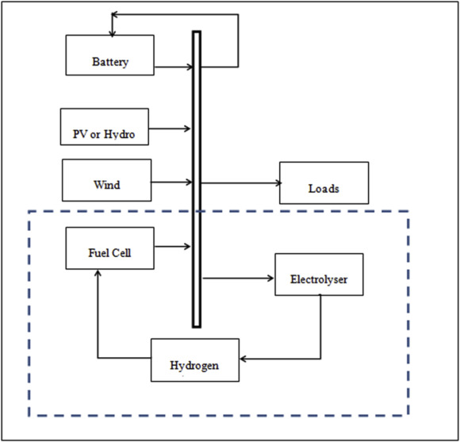

Fig. 1. Hybrid wind/photovoltaic system with hydrogen storage supplying a load (Amrouche *et al*, 2016).

A bus is used to transfer the available energy to the load and the system is managed as follows ([Fig. 2](https://www.sciencedirect.com/science/article/pii/S0360319916309478#fig2)) (Amrouche *et al*, 2016).

When the energy demand is lower than the production of wind and solar panels, the excess energy is sent to the electrolyzer to produce and store hydrogen (Amrouche *et al*, 2016).

When the energy demand exceeds the available energy capacity, the stored hydrogen is used to generate electricity via the fuel cell (Amrouche *et al*, 2016).

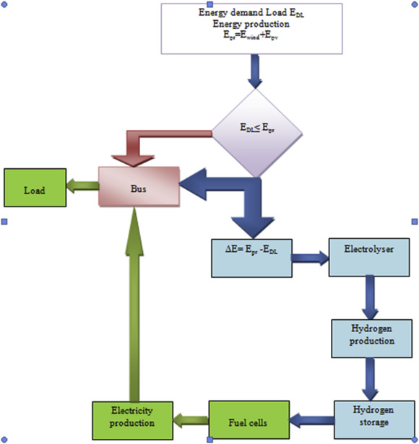

Fig. 2. Energy management of a Wind/PV system with hydrogen storage (Amrouche *et al*, 2016).

Various research works proposed different wind or hybrid systems with hydrogen storage, the overall hybrid structure is shown in [Fig. 3](https://www.sciencedirect.com/science/article/pii/S0360319916309478#fig3). Some of the proposed structures have been implemented in renewable energy power plants systems. In wind energy conversion system, HES with all advantages (higher energy density and lower per volume than a gasoline, …) is one of the best storage solutions for suppressing fast wind power fluctuations (Amrouche *et al*, 2016).

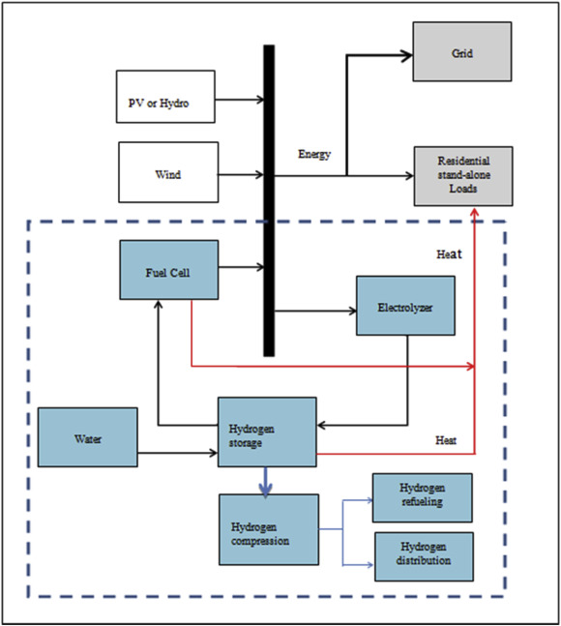

Fig. 3. Production of energy and heat of a hybrid wind/PV(or hydro) system with hydrogen storage (Amrouche *et al*, 2016).

# **2.0 Mechanical storage**

## 2.1 Pumped hydro energy storage (PHES)

Pumped Hydro Energy Storage (PHES) system consists of a pumped hydro system with two large water reservoirs (upper and lower), an electric machine (motor/generator) and a reversible pump-turbine group ([Fig. 6](https://www.sciencedirect.com/science/article/pii/S0360319916309478#fig6)) (Amrouche *et al*, 2016).

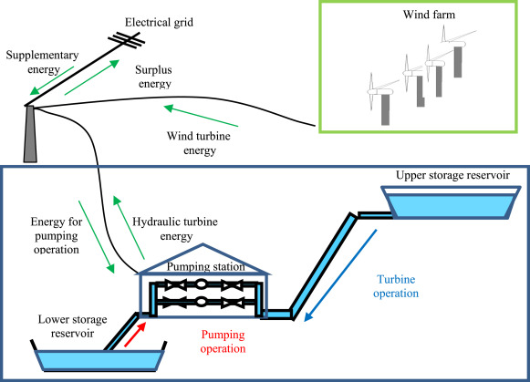

Fig. 6. Hybrid pumped hydro/wind energy (Amrouche *et al*, 2016).

## 2.2 Compressed air energy storage (CAES)

The basic idea of compressed air energy storage (CAES) is to compress air using inexpensive energy, and the compressed air (released into a combustion turbine generator system and sent through the system's turbine) is used to generate energy (Amrouche *et al*, 2016).

It can be concluded that CAES is an interesting alternative for wind farms. In offshore wind systems, pipelines are used as an alternative storage for compressed air. The proposed system ([Fig. 7](https://www.sciencedirect.com/science/article/pii/S0360319916309478#fig7)) is able to provide large energy storage (Amrouche *et al*, 2016).

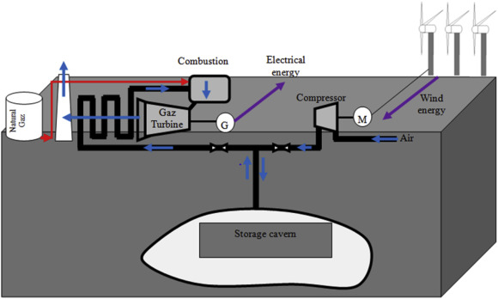Fig. 7. Compressed air energy storage system using an underground geologic structure (Amrouche *et al*, 2016).

# **3.0 Electrical storage**

Electrical storage is mainly realized by applying super capacitor and magnetic storage (Amrouche *et al*, 2016).

## 3.1 Super capacitor energy storage (SES)

It is known as electric double-layer capacitors, as super capacitors (SC), electrochemical double layer capacitors (EDLCs), or ultra-capacitors. They use polarized liquid layers between conducting ionic electrolyte and conducting electrode to increase the capacitance. They allow a much higher energy density, with a high power density, but the voltage varies with the energy stored and it has a higher dielectric absorption. The most important parameter is the relatively low, state-of-charge-dependent maximum voltage of 2.5 V and a great efficiency (around 95%). In wind energy conversion system, SES are used to suppress fast wind power fluctuations but at a small time scale. Thus, they can be considered only as a support for wind turbines systems and are generally combined with a battery system in a hybrid storage system (Amrouche *et al*, 2016).

# **4.0 Thermal energy storage (TES)**

Thermal energy storage stocks thermal energy by heating or cooling various mediums in enclosures in order to use the stored energy for heating, cooling and power generation [[33]](https://www.sciencedirect.com/science/article/pii/S0360319916309478#bib33). The input energy to a TES can be provided by an electrical resistor or by refrigeration/cryogenic procedures. In buildings and industrial processes, about half of the energy is consumed in the form of heat. This consumption varies on a daily, weekly and seasonal basis, the varying energy needs can be balanced by the storage system (Amrouche *et al*, 2016).

TES systems can also be used to mitigate the intermittency of renewable energy sources, by storing heat in water tanks, molten salts or another material. The recovered heat/cold from TES is used by a heat engine to produce electrical energy. Thermal energy storage employs different technologies to store energy at temperatures varying from −40 °C to more than 400 °C (Amrouche *et al*, 2016).

## 4.1 Sensible heat storage

This is the simplest technology and is based on heating or cooling a liquid or solid storage medium. The most widely used medium is hot water, which is a well-known and a cost efficient technology for thermal energy storage [[34]](https://www.sciencedirect.com/science/article/pii/S0360319916309478#bib34). Other materials such as cement and concrete based on common ceramics, natural stones (marble, granite, clay), and polymers are also commonly used [[34]](https://www.sciencedirect.com/science/article/pii/S0360319916309478#bib34). Moreover, some waste materials from several industrial processes are being introduced for sensible heat storage systems [[34]](https://www.sciencedirect.com/science/article/pii/S0360319916309478#bib34). Sensible heat storage is not only cost efficient and environmentally friendly, but it can be easily stored as bulk material, enabling simpler system design. Hot water tanks are used in water heating systems based on solar energy and in co-generation (i.e. heat and power) energy supply systems. The storage efficiency varies from 50 to 90%. State-of the-art projects have shown that water tank storage is a cost-effective storage option [[35]](https://www.sciencedirect.com/science/article/pii/S0360319916309478#bib35). The sensible heat storage is a low density technology but this disadvantage is counterbalanced by its low cost. The efficiency of water storage systems can be further improved by optimizing the water stratification and thermal insulation of the tank. Present research work aims to achieve super insulation with a thermal loss rate of 0.01 W/mK at 90 °C and 0.1 mbar (Amrouche *et al*, 2016).

## 4.2 Thermo-chemical storage (TCS):

Thermo-chemical storage offers higher storage capacity (300 kWh/m3) than sensible heat and PCM storage systems [[33]](https://www.sciencedirect.com/science/article/pii/S0360319916309478#bib33). TCS can be used to store and release heat and cold by a reversible thermo-chemical process such as adsorption (adhesion of a material to the surface of another substance). Although this process is highly efficient (75–100%), it is still in the development phase and an appreciable effort must be done to overcome some important barriers, such as corrosion, poor heat and mass transfer performances (Amrouche *et al*, 2016).

The storage of variable renewable energy in the form of thermal energy, increases the share of renewables by mitigating their intermittency. Apart from the heating and cooling applications, TES enables solar power plants to operate like a conventional power plant, generating reliable electricity. Moreover, integrated thermal storage provides the ability to shift electricity to meet various load profiles. Solar thermal-driven electricity generation systems will grow consistently along with the need for storage device components (thermal storage devices, fluids, heat exchangers, …) and system controls of temperature, pressure and flow [[36]](https://www.sciencedirect.com/science/article/pii/S0360319916309478#bib36). The development of solar thermal technology offers an opportunity for the application and dissemination of renewable electricity systems at large, small and micro-generation level. For instance, solar thermal storage becomes particularly important for the CSP (concentrating solar power) technology where solar heat can be stored for later electricity production. For large scale CSP power plants, molten salt represents a flexible, efficient and cost-effective technology. In these CSP systems, molten salt can be used both as a thermal energy storage medium as well as heat transfer fluid (Amrouche *et al*, 2016).

Despite the fact that there is a great potential for the application of TES systems in renewable energy and in recycling waste heat in conventional technologies, there is a need to overcome some important barriers. The major obstacles to market entry are mainly the actual costs and improvements of stability of the material performances (Amrouche *et al*, 2016).

# **5.0 Comparison of several storage methods**

## 5.1 The price of several types of storage

Table 2. Capital cost of ES (Amrouche *et al*, 2016).

| **System** | **Capital cost** | | |
| --- | --- | --- | --- |
| **$ (kW)** | **$ (kWh)** | **$ (kWh per cycle)** |
| PHES | 600–2000 | 5–100 | 0.1–1.4 |
| CAES | 400–8000 | 2–50 | 2–4 |
| FES | 250–350 | 1000–5000 | 3–25 |
| FLA | 300–600 | 200–400 | 20–100 |
| Ni–Cd | 500–1500 | 800–1500 | 20–100 |
| Li–ion | 1200–4000 | 600–2500 | 15–100 |
| NaS | 1000–3000 | 300–500 | 8–20 |
| VR | 600–1500 | 150–1000 | 5–80 |
| ZnBr | 700–2500 | 150–1000 | 5–80 |
| FC | 10,000+ | – | 6000–20,000 |
| SES | 100–300 | 300–2000 | 2–20 |
| Elmes | 200–300 | 1000–10,000 | – |

Table 2. Main techno-economic parameters for the storage technologies (Cebulla *et al*, 2017).

| **Technology** | **Investpower [€/kWel]** | **Investenergy [€/kWhel]** | **ηcharge [-]** | **ηdischarge [-]** |
| --- | --- | --- | --- | --- |
| H2 | 1200 | 1 | 0.75 | 0.62 |
| Li-ion | 50 | 150 | 0.97 | 0.97 |
| aCAES | 570 | 47 | 0.84 | 0.89 |
| Redox-flow | 630 | 100 | 0.92 | 0.92 |
| PHS | 450 | 10 | 0.91 | 0.91 |

## 5.2 Performance of several storage types

Table 5. Battery technologies and characteristics (Kourkoumpas *et al*, 2018).

| **Battery Technology** | **Specific Energy (Wh/kg)/Power Density (W/kg)** | **Cycle life** | **Round-trip Efficiency** |
| --- | --- | --- | --- |
| Sodium-sulfur (Nas) | 150–240 Wh/kg | 4500–5000 cycles at 80% DoD | 75–90% |
| Vanadium Redox flow Battery | 10–70 kWh/m3 | several thousand cycles | 85% |
| 16–33 kWh/m3 | >12,000 at 100% DoD | 75–80% |
| Lead Acid (PbO2) battery (conventional battery) | 30 Wh/kg–150 W/kg | 1000 cycles | 85–90% |
| 30–50 Wh/kg | 500–1000 cycles | 65–80% |
| Lithium ion (Li-ion) battery | 200 Wh/kg | 3000Cycles at 80% DOD | 95% |
| Nickel Cadmium (NiCd) battery | 50–75 Wh/kg | 2000–2500 cycles | 85% |

Table 1. Most used storage technologies in wind energy conversion systems (Amrouche *et al*, 2016).

| **Energy storage (ES)** | **Technologies** | | | **Time scale** | **Application in WECS** | **Efficiency** |
| --- | --- | --- | --- | --- | --- | --- |
| Electrochemical | Batteries (BS) | Nickel–cadmium storage (NCS) | | Medium (minutes) | X | 60–70 |
| Nickel–hydrogen storage (NHS) | |
| Nickel–metal hydride | |
| Nickel–zinc | |
| Sodium–sulfur storage (NaS) | | 86–89 |
| Sodium–nickel chloride | |
| Lithium–ion storage (LIS) | | 90–95 |
| Zebra | | 90 |
| Lead–acid storage (LAS) | Flooded (FLA) | 75–85 |
| Valve-regulated (VRLA). | 75–85 |
| Flow batteries storage (FBS) | Vanadium redox storage (VRS) | | Medium (hour) | X | 70–80 |
| Polysulphide bromide storage (PSBS) | | 75 |
| Zinc bromine storage (ZnBrS) | | 75–80 |
| Hydrogen (HES) | Hydrogen (HES) | | | Long | X | 65–75 |
| Mechanical (MES) | Flywheel energy storage (FES) | | | Short (seconds) | X | 80–90 |
| Pumped hydro energy storage (PHES) | | | Long (hours) | X | 70–85 |
| Compressed air energy storage (CAES) | | | Long (hours) | X | 64–75 |
| Electrical (Eles) | Super capacitor energy storage (SES) | | | Short (seconds) | X | 90–98 |
| Electromagnetic (ElmES) | Superconducting magnetic energy storage (SMES) | | | Short (seconds) |  | 90–99 |
| Thermal (TES) | Thermal (TES) | | | Medium | X | 80–90 |

## 5.3 Environmental friendliness of several storage types

Tabular data for the GHG emissions per kg of produced battery presented in [Table 7](https://www.sciencedirect.com/science/article/pii/S0306261918313527#t0035) and [Table 8](https://www.sciencedirect.com/science/article/pii/S0306261918313527#t0040)according to the findings of [[66]](https://www.sciencedirect.com/science/article/pii/S0306261918313527#b0335), [[67]](https://www.sciencedirect.com/science/article/pii/S0306261918313527#b0340) respectively pointing that the most environmental intensive batteries in terms of their production is the lithium ion and the [nickel metal hydride](https://www.sciencedirect.com/topics/engineering/nickel-metal-hydride) (Kourkoumpas *et al*, 2018).

Table 7. Characterized GHG emissions per kg of produced battery and MJ of capacity (Kourkoumpas *et al*, 2018).

| **Type of Battery** | **GHG emissions (kgCO2,eq/kg of battery)** | **GHG emissions (kgCO2,eq/MJ)** |
| --- | --- | --- |
| Lead Acid | 0.9 | 5–7 |
| Lithium-ion (NMP solvent) | 12.5 | 17–27 |
| Lithium-ion (water solvent) | 4.4 | – |
| Nickel cadmium | 2.1 | 10–15 |
| Nickel metal hydride | 5.3 | 16–20 |
| Sodium sulphur | 1.2 | 2 |

Table 8. LCA studies on batteries (Kourkoumpas *et al*, 2018).

| **Battery Typology** | **System boundaries** | **GHG emissions (kgCO2,eq/kg of battery)** |
| --- | --- | --- |
| LiFePO4 | Manufacturing | 22 |
| Nickel cobalt manganese Li-ion | Manufacturing | 22 |
| Li-ion | Manufacturing | 12 |
| LiMnO4 | Manufacturing and end-of-life | 6 |
| LiFePO4 (NMP solvent) | Manufacturing and end-of-life | 41.04 |
| LiFePO4 (water solvent) | Manufacturing and end-of-life | 31.71 |
| Nickel–metal hydride | Manufacturing, operation and end-of-life | 54.6 |
| Li-ion | Manufacturing, operation and end-of-life | 40.5 |

# **6.0 Transmission investment costs**

|  |  |  |
| --- | --- | --- |
| **Offshore wind** |  |  |
| **Transmission investment costs** | HVDC cables | 1324.3–2207.1 €/MW·km |
|  | HVDC converters | 92.3 to 153.8 M€/MW |

Reference：(Dedecca *et al*, 2018)

At present there are signifcant TEC constraints in the north of England and Scotland which are preventing the connection of new generation projects.

Reference：Tidal Power in the UK Oct07

With the introduction of British Electricity Trading and Transmissions Arrangements (BETTA) in 2005, the Scottish network became an integral part of the GB network. In anticipation of this, many generators submitted bids to be connected onto the grid but most of these did not have planning permission, which can take many years to achieve.

Reference：Tidal Power in the UK Oct07

# **7.0 The price of excess electricity**

Excess electricity generated by prosumers is fed into the national grid and is assumed to be sold for a transfer price of 0.02 €/kWh (Child *et al*, 2018).

[Fig. 6](https://www.sciencedirect.com/science/article/pii/S0142061518308019#f0030) shows the real purchase and sale prices of energy in the market (Domínguez-Navarro *et al*, 2019).

It is the hourly prices of the Spanish [electric market](https://www.sciencedirect.com/topics/engineering/electric-market) (Domínguez-Navarro *et al*, 2019).

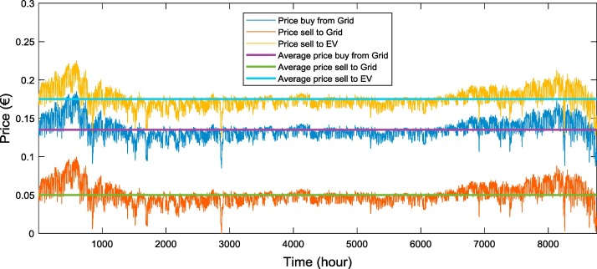

Fig. 6. Hourly prices of energy (Domínguez-Navarro *et al*, 2019).

Table 3. Economic costs (Domínguez-Navarro *et al*, 2019).

|  |  |  | **Price** |
| --- | --- | --- | --- |
| **Wind Generators** |  | Sell energy to EV | 0.175 €/kWh |
| **Solar PV panels** |  | Sell energy to grid | 0.055 €/kWh |

# **The advantages and disadvantages of several common storage methods**

## Sodium nickel chloride batteries

Advantage：

The sodium nickel batteries are suitable for bulk storage in large renewable energy power plants, due to their long discharge time, long cycle life and fast response (Amrouche *et al*, 2016).

Disadvantage：

However, their use is mainly limited by the fact that heat is required to keep the molten state temperature. Moreover, molten sodium reacts dangerously with water and caused fires in reported incidents (Amrouche *et al*, 2016).

## Lithium ion (Li–ion) batteries

Advantage：

Lithium ion batteries are the most popular form of storage in the world and represent 85.6% of deployed energy storage system in 2015 (Amrouche *et al*, 2016).

Although this type of battery has the highest price, it provides the ability to store renewable energy because it shows the lowest cost per cycle (Amrouche *et al*, 2016).

Disadvantage：

The huge demand for lithium due to portable devices, hybrid electric vehicles and electric vehicles, may lead to dramatically expensive large scale storage systems (Amrouche *et al*, 2016).

## Hydrogen energy storage (HES)

Advantage：

Hydrogen is a key enabling technology for the advancement of renewable energy applications for electricity generation including wind and solar sources (Amrouche *et al*, 2016).

In a wind system or a hybrid wind/photovoltaic (or hydro) system supplying a load (Fig. 1), a battery system can be added for short term storage and also to stabilize the system against fluctuations of energy sources (Amrouche *et al*, 2016).

In wind energy conversion system, HES with all advantages (higher energy density and lower per volume than a gasoline, …) is one of the best storage solutions for suppressing fast wind power fluctuations (Amrouche *et al*, 2016).

## Compressed air energy storage (CAES)

Advantage：

It can be concluded that CAES is an interesting alternative for wind farms. In offshore wind systems, pipelines are used as an alternative storage for compressed air (Amrouche *et al*, 2016).

## Thermo-chemical storage (TCS):

Advantage：

The storage of variable renewable energy in the form of thermal energy, increases the share of renewables by mitigating their intermittency. Apart from the heating and cooling applications, TES enables solar power plants to operate like a conventional power plant, generating reliable electricity (Amrouche *et al*, 2016).

Disadvantage：

Although this process is highly efficient (75–100%), it is still in the development phase and an appreciable effort must be done to overcome some important barriers, such as corrosion, poor heat and mass transfer performances (Amrouche *et al*, 2016).

Despite the fact that there is a great potential for the application of TES systems in renewable energy and in recycling waste heat in conventional technologies, there is a need to overcome some important barriers. The major obstacles to market entry are mainly the actual costs and improvements of stability of the material performances (Amrouche *et al*, 2016).